Phase III- 29.11.2017

ABSTRACT OF SCIENTIFIC REPORT

Synthesis, characterization and anode testing for Li-ion batteries of Sn-based optimized multicomponent nanocomposites

At this stage, they were synthesized using laser-based method of laser pyrolysis, characterized by multiple techniques and tested in the form of anodes for lithium ion batteries, as well as by cycling voltammetry a series of nanoparticles optimized on the tin, type Sn-Fe-N@polycarbosilazan starting from volatile precursors Sn(CH₃)₄, (SnMe₄, TMS), Fe (CO)₅ and [(CH₃)₃Si]₂NH (HMDS) and another carrier gas, NH₃ in anoxic medium.
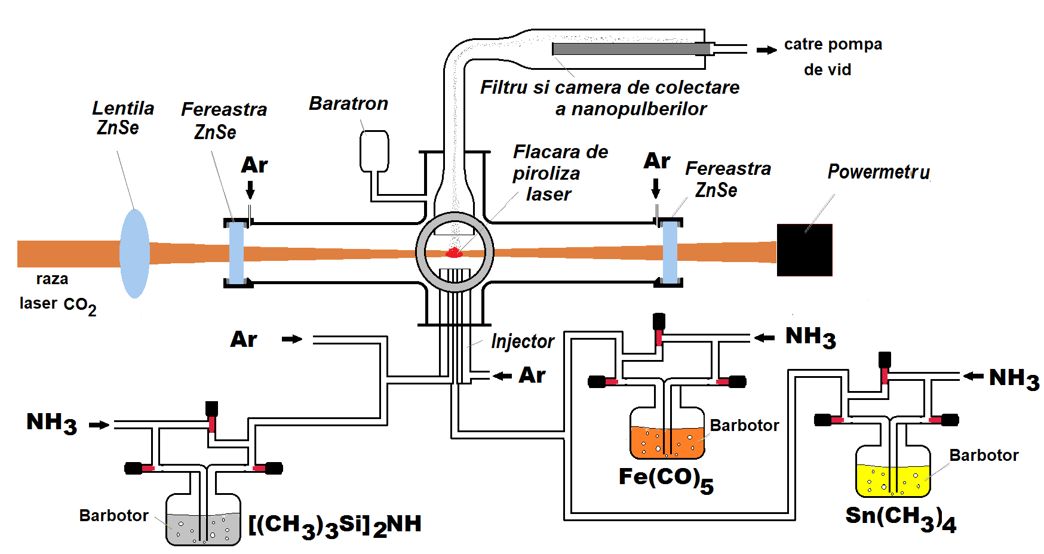
Fig.1 Scheme of the Sn-Fe-N@polycarbosilazane nanocomposites synthesis by laser pyrolysis

Tabelul nr.1 Process parameters for the laser pyrolysis of Sn-Fe-N@polycarbosilazane type nanocomposites
Runs | Gas/vapor flows through inner central nozzle [sccm] |  |  |  | Gas/vapor flows through middle annular nozzle [sccm]
 | Sn(CH₃)₄  antrenat | NH₃>  >Sn(CH₃)₄ | Fe(CO)₅  antrenat | NH₃>  >Fe(CO)₅ | HMDS  antrenat | NH₃>  >HMDS | Ar
SnFeNSi1 | 2.15 | 4.3 | 0.54 | 4.3 | 2.8 | 65 | 65
SnFeNSi2 | 2.15 | 4.3 | 0.54 | 4.3 | 1.4 | 32.5 | 85
SnFeNSi3 | 2.15 | 4.3 | 0.54 | 4.3 | 0.7 | 16.25 | 113.7
SnFeNSi4 | 2.15 | 4.3 | 0.54 | 4.3 | 5.6 | 150 | -
SnFeNSi5 | 2.15 | 4.3 | 0.54 | 4.3 | 1.87 | 43.3 | 86.7
Working pressure p = 450 mbar; Laser power density in the reaction zone = 3500 W/cm²;
Ar flow through annular external nozzle = 2500 sccm; Ar windowflow Φ_{window} = 150 sccm; Φ_{inner nozzle}= 0.5 mm; Cross-sectional area ratios of inner nozzle, internediar nozzle and external nozzle 1:13:250

X-ray diffractograms of three nanocomposite powders are shown in FIG. 2. All identified crystalline phases contain tin, the predominant one corresponding to the β-Sn tetragonal phase (JCPDS 00-004-0673). The mean β-Sn crystal size was evaluated using the Debye-Scherrer formula from peak (301) as 25.9 nm for SnFeNSi1, 22.1 nm for SnFeNSi2 and 22.7 nm for the sample with the highest Sn content - SnFeNSi3. The identified minority phases, resulting from
interactions between Sn atoms and Fe atoms/clusters formed by the decomposition of SnMe₄
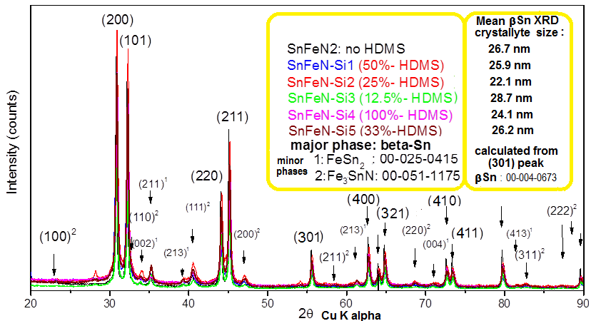
Fig.2 X-Ray diffractograms Sn-Fe-N@polycarbosilazane nanopowders
(TMT) and Fe(CO)₅ in the presence of NH₃ were Fe₃SnN ternary nitride (JCPDS 00-051-1175) and the two stoichiometric alloys Fe-Sn: FeSn₂ (JCPDS 00-025-0415) and Fe₃Sn (JCPDS 01-073-2029). Absence of crystalline phases containing Si can be expected that because of previous HMDS laser pyrolysis experiments, the resulting crude powders had the amorphous structure. By lowering the NH₃-entrained HDMS vapors, constantly maintaining Fe and Sn precursor flows (together with corresponding NH₃ streams) a decrease in the Si content and consequently an increase in Sn and Fe content from to SnFeNi1 to SnFeNSi2 and to the SnFeNSi3 powders is expected.. This trend is confirmed by the elemental estimation extracted from EDS analysis

Table nr.2 Elemental composition estimation of tin-base nanopowders eztracted from EDS analysis
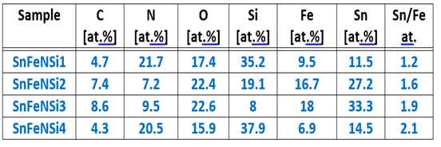

(see Table 2), which also shows that the atomic ratio Sn:Fe increases at the same time from 1.2 to 1.6 and 1.9, even if the ratio between TMT and Fe(CO)₅ precursors was maintained constant at 4. The lower Sn: Fe ratio in the powders obtained than in the precursors introduced can be explained by the lower energy required for the total decarbonation of Fe(CO)₅ (149 kcal/mol ) than required for the total demethylation of Sn(CH₃)₄ (220 kcal/mol).
All samples contain a significant amount of oxygen (~ 17-23% at.), even though these nanoparticles were obtained under anoxic conditions in the laser pyrolysis flame. This presence can be explained by the post-synthesis interaction of powders with atmospheric oxygen in the air. The porous carbsilazane shell can allow O₂ to penetrate it, resulting in the superficial oxidation of the cores.
The XPS analysis, which provides information on the composition of the surface,. For SnFeNSi3 sample, XPS shows the presence of Sn²⁺ (85.67%, calculated from the peak centered at 486 eV) accompanied by minor proportions of Sn⁴⁺ (11.98% of the peak at 488.3 eV) and unoxidized Sn⁰ metal (2.35% the weak peak at 483.9 eV) in the superficial layer, as shown in FIG. 3b. The superficial bivalent tin presence (probably disordered /amorphous SnO) is consistent with the proposed partial oxidation mechanism in the presence of O₂ after the penetration of the silicon-based porous amorphous coating. In the XPS spectrum of Fig. 3a, all elements detected in EDS raw nanoparticles were also found in the surface of the SnFeNSi3 sample with the smallest silicon content due, as expected, to the very small size of the nanocomposites, and also of nanoparticle shells.

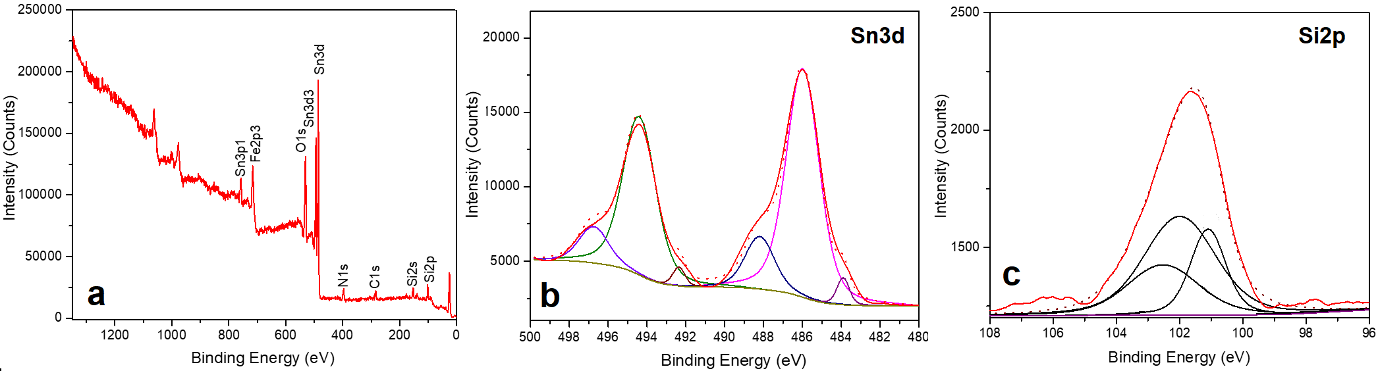
Fig.3 Sample SnFeNSi3 XPS analysis: survey spectrum (a), Sn3d zone (b) and Si2p zone (c).

The presence of iron-containing phases in these nanocomposites was also confirmed by magnetic hysteresis curves showing almost superparamagnetic behavior for SnFeNSi2 and SnFeNSi3 samples (coercivity values of 1.9 and 1 kA/m respectively), confirming the very small size of these crystallites. The slightly lower saturation of the SnFeNSi3 iron sample (1.48 emu/g) compared to that of SnFeNSi2 (2.48 emu/g) may be explained by a weaker crystallinity of that sample (visible in the X-ray diffractogram of Fig. 2) and may be related to the lower sensitivity flow introduced into the reaction zone (through the annular nozzle) which induced a lower flame temperature.

Fig.5 b: SnFeNSi1 nanopowder FT-IR spectrum

The infrared spectrum of the SnFeNSi1-rich powder of 400-1300 cm⁻¹ presented in Fig. 5b contains: the peak of ~ 450 cm⁻¹ which was attributed to the Si-N-Si symmetric stretching mode, while the main peak at 950 cm⁻¹ was attributed to Sn-N-Si antisymmetric elongation vibrations. In our case, the broad band between 1000 and 800 cm-1 can be attributed to a combination of Si-O, Si-N and Si-C bonds. As discussed above, this powder has been synthesized in ammonia-rich medium and the HMDS precursor is oxygen-free so that Si-O groups can only be formed by post-synthesis exposure to ambient air when molecular oxygen reacts with labile bindings amorphous /crosslinked carbosilazane. Also, the small peak around 1260 cm⁻¹ can be attributed to vibrations of Si-CH₃ groups (resulting from laser-induced HMDS decomposition). The deconvoluted XPS spectrum of the Si2p core levels in the SnFeNSi3 sample (Figure 3c) also confirms the presence of different silicon bonds in the nanoparticle shell: Si-C (~ 101.1 eV),
The wide scale distribution of nanoparticles (from 5 to ~ 120 nm) in all three samples was
highlighted by TEM images fig. 6 left. An explanation for this broad distribution may be related
to the low melting point of Sn metal (232°C) and the special configuration of the injector used.
Fig.6 TEM images of nanoparticles from a: FeNSi1; b: FeNSi2; c: FeNSi3 sample
Thus, by decomposing TMT molecules following interaction with the (NH₃) sensitizer in the center of the reaction zone (temp.~ 700-800°C), the Sn atoms present will coagulate and form spherical liquid nanoparticles, which have a natural tendency to form larger drops through coalescence after collision. These nanoparticles serve as a substrate for decomposing activated HMDS molecules, forming a solid C-N-Si-H coating (which is not soluble in liquid Sn), which prevents coalescence in larger nanoparticles, even if the hot core is still in the liquid phase. This process takes place first for the droplets located at the periphery of the central area, where the excited HMDS molecules reach through the diffusion from the annular flow, while those in the middle of the central flow are uncovered and grow and finally covered with the amorphous crosslinked polymeric crust. This process is complicated by the presence of Fe atoms and the groups resulting from the decarbonylation of Fe(CO)₅ molecules in the presence of the laser excited sensitizer. According to the Fe-Sn phase diagram, the presence of even a few percent Fe in Sn greatly increases melting temperature of the resultant alloy (770°C for 3% Fe, for example) to 1134°C for 33% atomic Fe corresponding to the FeSn₂ alloy. This behavior implies that Sn-Fe nanoparticles (and even ternary nitride) solidify very quickly, eventually being further coated with amorphous shell. Thus, they can't increase by total coalescence after collision, forming in turn fractal aggregates, visible in all the lower resolution images of Fig. Another very interesting feature of these nanocomposites is the presence of relatively short amorphous nanoparticles with diameters between 5 and 15 nm, visible in the TEM image of the SnFeNSi1 sample (Fig. 6a - left), which so far have not been reported to be synthesized by the method of laser pyrolysis, where the residence time of reactive species in the reaction zone is very short, being in the order of milliseconds. Furthermore, in Fig. 6b-left, bare shells and very short nanotubes with small catalytic particles encapsulated at their tips can be viewed. The appearance of these elongated nanostructures suggests that Sn-Fe nanoparticles can act as a catalyst for their growth, in this case, pure carbon is replaced with a material containing Si, C and N from the decomposition of HMDS, NH3 and possibly the CH3 groups provided by TMT. The HRTEM images on the right side of Fig. 6 show the presence in all samples of spherical nanoparticles having a core-shell structure, the thickness of the shell being about 5 nm. These conformal coatings have a lower contrast compared to metallic cores and a disordered porous structure. In the image corresponding to the sample with the smallest Si content, two concentric coats can be distinguished. The inner one can be attributed to the disordered oxide shells resulting from superficial oxidation due to exposure to air. The crystalline structure of the nanocomposite cores is also evidenced by the presence of crystalline planes having an interplanar distance ~ 0.47 nm (corresponding to Fe₃Sn (100) or FeSn₂ (110)) in the high resolution TEM image of Fig. 6b of the SnFeNSi2 sample, thus confirming the results XRD.

Electrochimical testings
Considering the complex composition and the difficulty of quantitating the individual chemical components of the anode materials investigated in this paper, it is difficult to estimate their theoretical lithic capacity. For this reason, anodic materials were tested by galvanostatic cycling between 0 and 2 V at a current speed of 200 mA/g for all samples. The first 4 cycles were performed with lower currents (the first 2 cycles at 50 mA/g and the next 2 cycles at 100 mA/g) to allow the formation of a good quality SEI layer. As can be seen from Fig. 7a, the three SnFeSiN anodes have a very different electrochemical performance when used as Li-ion battery anodes. Based on the EDX and XRD analysis, it can be assumed that the main contributor to the lithiation process is β-Sn nanoparticles and a smaller amount of FeSn₂ nanoparticles. The rest of the elements, and especially silicon, most likely present in the form of carbides, nitrides or silicon oxides, are inactive against Li⁺ ions. Even if such components do not suffer from lithiation, they could provide a good buffer against the significant change in the volume that Sn suffers during the alloying and ion neutralization process of Li. This hypothesis is also confirmed by the potential evolution during the first lithiation cycle of Fig. 7b one can again correlate the better performance of SnFeNSi3 sample with the highest Sn content between the three anode materials.SnFeNSi3 presents several plateaux: the one at higher potential values, probably due to
Fig.7 a) Discharge capacity of the three anodic material SnFeNSi1,2 si 5; b) Potential vs. capacity during first cycle for the same anodic materials

SEI layer formation and below 1V for alloying Sn with lithium. Several other smaller plateaux can be observed in the potential evolution of the capacity corresponding to the stepwise lithium / luteinizing processes of active Sn material and its alloy. The main delimitation plate during the unloading cycle is about 0.5 V relative to the Li, Li⁺ reference electrode.
SnFeNSi3 sample performance is the best of three anode materials with discharge capacities of approximately 500 mAhg⁻¹ for the first 20 cycles when cycled at a current of 200 mAg⁻¹. Irreversible capacity is also the lowest because the current efficacy for this sample is approximately 70% in the first cycle compared to 60% for the SnFeNSi2 sample and less than 50% for the SnFeNSi1 sample. This could be related to the good ability to buffer inactive materials for the greater amount of Sn present in this sample. After the first cycle, the current efficacy for SnFeNSi3 is approximately 94%, with a decrease of about 90% after 20 cycles, when as can be seen from Fig. 7a capacity drops strongly. This could be the result of an extended fissure of the anodic nanomaterial to the lithium and therefore the Sn particles lose their electrical contact and become inactive

Fig. 8 a) Cyclic Voltammograms (first cycle) of: SnFeNSi1,2si 3 nanocomposites ; b) Superposed Cyclic Voltammograms pt. 1st, 2nd, 5th, 10th and 20th cycle for SnFeNSi3 nanocomposite

The cyclic voltamograms obtained for the three probes with potential cycles of between 0.0 and 2.0 V relative to Li, Li⁺ reference electrode with a scan rate of 0.5 mV/s are shown in Fig. 8a. The most significant result obtained from cyclic voltammetric experiments is that they confirm the behavior already observed during the galvanostatic cycle. The SnFeNSi3 sample presents the best electrochemical performance during the litter, followed by the SnFeNSi2 sample, while SnFeNSi1 has the lowest performance. A strong drop in capacity was also recorded for all samples during volumetric cycling experiments. In Fig. 8b, the electrochemical response diminished for the SnFeNSi3 sample can be observed in 20 consecutive cycles. As expected, the lithiation /delithiation peaks are better defined for the SnFeNSi3 sample that showed the highest capacity. They occur at -0.52, -0.61, -0.32 and -0.1 V in cathodic scanning, similar to other literature reports and correspond to the Li_{x}Sn alloy formation steps of the material active based on Sn. The oxidation peaks at 0.1, 0.51, 0.66, 0.74 and 0.8 V obtained during scanning in the anode direction are due to the Li_{x}Sn alloy grafting steps. The peaks observed during the cyclic voltammetric experiments are consistent with the corresponding potential platters obtained during the galvanostatic cycle (Figure 7b). The difference between the voltamograms of the first and second cycles of the SnFeNSi3 sample is given by SEI (Solid Electrolyte Interface) formation during the first cycle, which occurs as a broad reduction peak around 1.2 V. Moreover, because the sample contains the intermetallic FeSn₂ electrochemically active, the litter peak corresponding to the irreversible lithium reaction (1) of the litter mechanism of this material is expected to be observed in the first cycle
FeSn₂ + 8,8 Li + 8,8 e⁻ Fe + 2 Li_{4,4}Sn (1) si Li_{4,4}Sn ↔ Sn + 4,4 Li + + 4,4 e⁻ (2)
It is interesting to note that for the SnFeNSi2 sample the peaks appear in the voltammogram at approximately the same potential values ​​as for the sample. SnFeNSi3, but with a slight intensity. Given the XRD and EDX assays, it can be argued that this difference is due, on the one hand, to the difference between the reports of electroactive components (nanoparticles of Sn and FeSn₂) with a Sn/Fe ratio of 1.6 for SnFeNSi2 and of 1.9 for the SnFeNSi3 sample. On the other hand, the SnFeNSi2 sample contains almost twice the amount of Si than the SnFeNSi3 sample, which means a larger buffering capacity, but, as already mentioned, happens at the expense of reduced capacity.
The results obtained during testing these materials as Li ion battery anodes provide a valuable contribution to how to perform future synthesis procedures to achieve higher performance anodes. This type of anode should have dimensions up to several nm with a smaller size distribution. An optimization of the Sn/Fe atomic ratio and the amount of buffers should improve the capacity and stability of such materials during lithiation/delithiation processes.

5. Conclusions
New core-shell nanocomposites with Sn-Fe-N type crystalline cores (composed of some
nanoparticles containing the main β-Sn phase and other intermetallic minor phases SnFe₂, Fe₃Sn and Fe₃SnN nitride) and disordered carbosilazanic coatings were successfully synthesized by laser pyrolysis. Their superficial oxidation that occurs after exposure to air has been demonstrated by EDS, XPS and FT-IR analyzes. Some of these nanoparticles have catalytic abilities, demonstrated by the formation of elongated nanostructures during the laser pyrolysis process. Their electrochemical performances as anodes in Li-ion batteries strongly depend on their tin content. The anode material with the highest percentage of tin shows the highest initial capacity dropping during the 40-50 loading/unloading cycles due to crack-induced degradation. In order to improve their performance as anions for the Li-ion battery, a future direction may be to introduce into the reaction zone the laser pyrolysis of the precursor with a higher carbon content, which can form conductive graphite structures (also capable of intercalating Li) and tin contents cores that also require a better buffer to withstand high volume variation during repeated littiation/delithiation

